**How to add Linux host to Jenkin**

## **Step 1 - Configure Jenkins Master Credentials(On jenkins server)**

### **Generate SSH Key**

$ su - jenkins

$ ssh-keygen

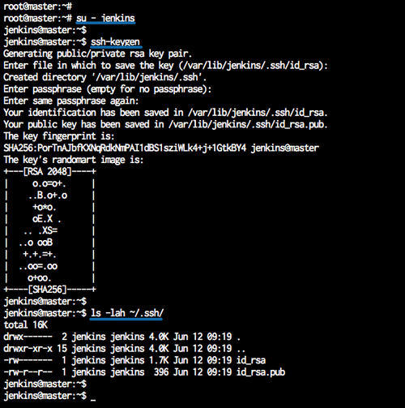

-copy and paste the public key in the slave server

-go inside the .ssh directory edit authorized key and paste the pub key.

Now install the publish over SSH plugin in jenkins

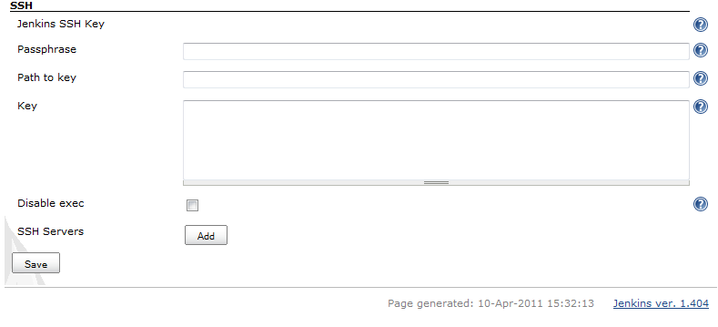

Add the private key which we have created before and save.

Now add the server in manage plugin > configure system

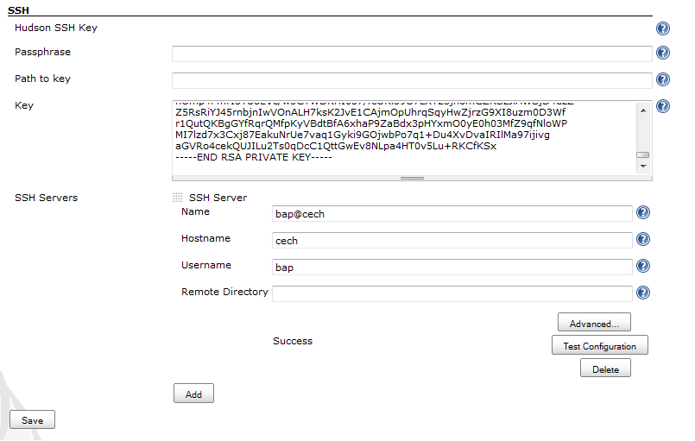

Now I open Jenkins and create a new project.

* Go to build section.
* Under the section “send file or execute command over ssh”  
  In Exec command tab paste the path of shell script.  
    
  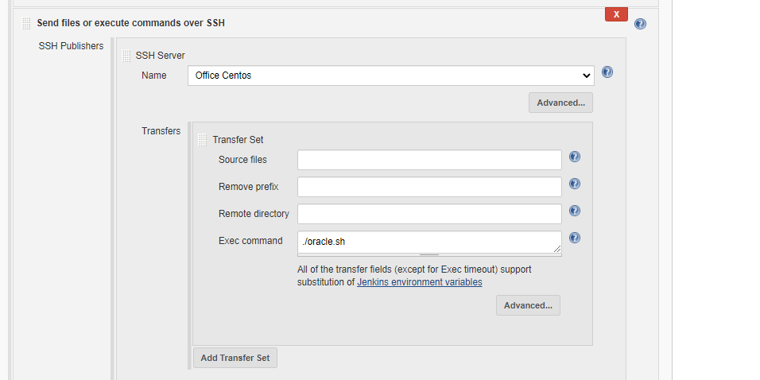

Note:*Table must be present in the database.*

|  |
| --- |
| #!/bin/bash  ls -1 /home/ >> /u01/app/oracle/**test.csv**  cat <<EOT >> /u01/app/oracle/**load.ctl**  LOAD DATA  INFILE '/u01/app/oracle/test.csv'  TRUNCATE  INTO TABLE **testcsv**  fields terminated by ","  (  **file_name**  )  EOT  sqlldr userid=username/password control='/u01/app/oracle/load.ctl'  rm -rf /u01/app/oracle/load.ctl |

**Files and table description in script:**

*testcsv-> table name*

*file_name -> column in table*

*load.ctl -> loader file name*

*test.csv -> csv file name having list of files in specific path.*